6167 Clark Center Avenue
Sarasota, Florida 34238
www.northstarcontrols.com
sales@northstarcontrols.com
Fax: (941) 926-2461 Tel: (941) 926-2454

Four Channel – Rack Mount Detector

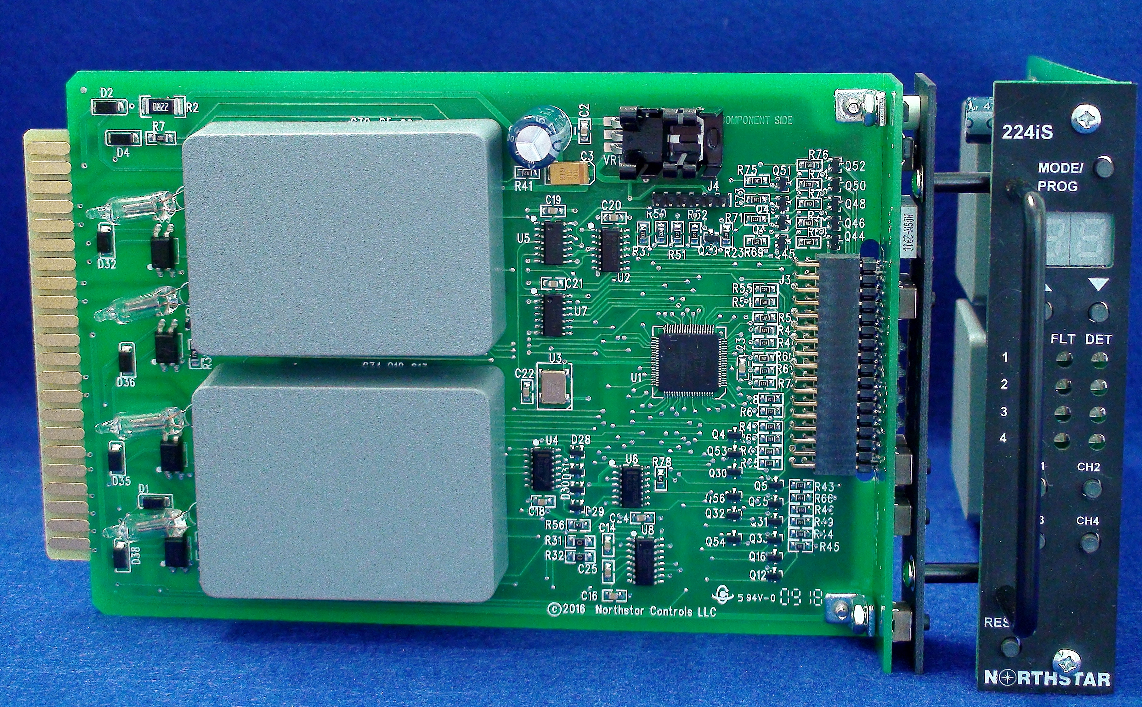

Model N224-iS Features:

- AVC Host enabled
- 7 selectable sensitivities per channel.
- 8 selectable frequencies per channel.
- Remote control of detector operations including Sensitivity, Frequency and Mode.
- Selectable Main and Axle Modes.
- Separate detect and fault indicators per channel.
- Fault diagnostics differentiate between
open and short circuit loop conditions.
- Detector reset from the front panel or card edge.
- Backward compatible with the N224I

Specifications/Selections
N224-iS Specifications

Operating Modes:
Axle Loop Mode (AL): High data rate with standard resolution data.
Standard Loop Mode (SL): High resolution data with a lower data rate.
The selected mode is for all channels.

Scanning:
Each channel is activated independently, minimizing crosstalk between adjacent loops connected to different channels of the same unit.

Front Panel Selections

LED display:
Two digit high brightness LED display, shows frequency, operational mode, sensitivity and fault status. Individual LED indicators show detect state, fault status and channel selected.

Push Buttons:
Mode/Prog
Press and hold to enter programming mode. The display will flash during programming.
Up/Down
Increase or decrease setting being programmed.
Channel
Selects the channel being examined. A blue channel indicator lights to show the channel currently selected.

Sensitivity:
Front panel sensitivity setting will only affect the detection of vehicles indicated by the detect leds and discrete outputs not the resolution of the transmitted data.
7 levels of sensitivity are available selected.
- dd = Channel Disabled.
- 1 = Low Sensitivity (0.64%)
- 7 = High sensitivity (0.01%)

Frequency:
The frequency of each channel may be viewed on the display to compare with adjacent detectors. When programming, the frequency may be changed by pressing the up/down keys. Frequencies are directly related to the loop to which the detector channel is connected. One of 8 different levels can be selected to avoid crosstalk with adjacent detectors.

Reset:
The detector may be reset by depressing the front panel Reset button. The detector may also be reset by the application of a logic-ground true signal applied to pin C of the edge connector. Data transmission will halt on detector power-on or reset or Mode change.

Channel Disable:
Each channel may be disabled by a selecting sensitivity ‘dd’. This will de-energize the loop for the selected channel. The frequency will read ‘—‘ on the display.

Discrete Outputs:
Optically Isolated Solid State Transistor.
Solid State Outputs are rated Maximum Collector Voltage 47V, ON voltage <1.5V at 50mA.

Factory Settings:
- Set to HI frequency
- Set to Medium sensitivity (5)

Ordering Information:

N224-iS = Four channel AVC Host enabled rack mount detector

Supply Voltage:
10.8 to 14.4VDC, 150mA max

Tuning:
Automatically tunes to proper loop and lead-in with application of power or upon reset or change of sensitivity/mode setting.

Inductance Range:
50uH to 1000uH with a Q factor greater than 5. The N224-iS is designed to interface with loops typically found in the tolling and related industries.

Temperature Range:
-34 C to +74 C.

Lead-In Length:
Consult factory.

Lightning and Transient Protection:
Loop inputs will withstand discharge of 2000V from a 10uF capacitor
across the loop connections or from either loop input to ground.

Mechanical:
International size card: 4.5” H x 7” L, conformal coated, 44 contact (2 x 22), gold plated double sided edge connector. 1.0” Wide panel with 3” x 1” handle.

Weight:
9 oz.

Communications:
Data is transmitted to and from the unit via the edge connector pins 19 (Detector Transmit) and 21 (Detector Receive). Signal levels are RS232 compliant and transmission rate is 19.2kbps (Standard Mode) or 38.4 Kbps (Axle Mode)

Remote Operation:
Remote control of the detector allows monitoring of the detector frequencies and ability to modify frequency and sensitivity from a remote location via the RS232 communications channel.

Indicators:
Front panel indicators include:
Channel Indicator – Blue, indicates the current channel being monitored on the display
Detect – Red, solid during detect. Flashes to indicate current fault.
Fault – Yellow, solid for current fault or flashing for historical fault.
Fault flash sequence is related to the type of fault sensed.
- Open = 1 blink, 1 space
- Short = 2 blinks, 1 space
- 25% inductance change = 3 blinks, 1 space

N224-iS Detector Connector –

Pin # | Functions
A | D.C. (-) Common
B | D.C. (+) Power
C | Reset
D & 4 | Loop Ch. 1
E & 5 | Loop Ch. 1
F | Output Ch. 1, Collector
H | Output Ch. 1, Emitter
J & 8 | Loop Ch. 2
K & 9 | Loop Ch. 2
L | Chassis Ground
M | No Connection
N | No Connection
P & 13 | Loop Ch. 3
R & 14 | Loop Ch. 3
S | Output Ch. 3, Collector
T | Output Ch. 3, Emitter
U & 17 | Loop Ch. 4
V & 18 | Loop Ch. 4
19 | Data Transmit
21 | Data Receive
W | Output Ch. 2, Collector
X | Output Ch. 2, Emitter
Y | Output Ch. 4, Collector
Z | Output Ch. 4, Emitter

L N224-iS-Rev A Specifications are subject to change without notice.

Northstar Controls L.L.C. warrants this product against defects in
Manufacturing and workmanship for one year from date of shipment
from the Northstar Controls L.L.C. factory.

